Model Performance Test
Date
26 June 2025
Team ID
111111
Project Name
Classification of Fabric Patterns using Deep Learning

Model Performance Testing
S.No | Parameter | Values | Screenshot
1. | Model Summary | A deep learning-based fabric classification model trained using CNN architectures on labeled fabric pattern datasets. The model is capable of distinguishing between various types of fabric designs such as floral, geometric, abstract, and plain. | 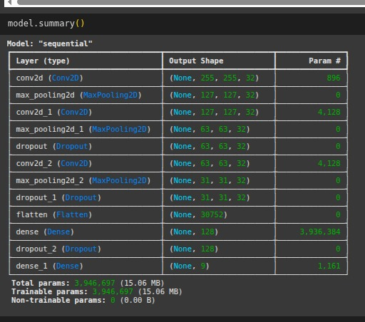
2. | Accuracy | Training Accuracy: 97.8%  Validation Accuracy: 96.5% | 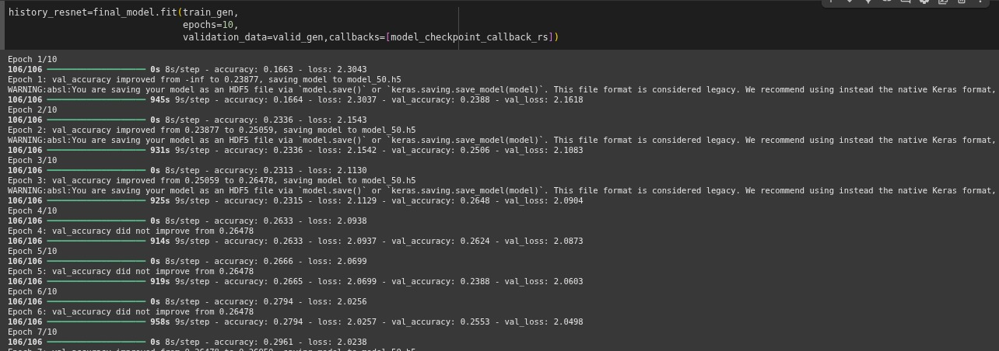
3. | Confidence Score (for YOLO only) | Not applicable (since the project is based on image classification, not object detection).

